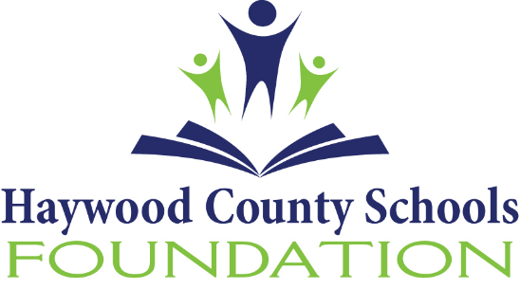

About the Haywood County Schools Foundation

The Haywood County Schools Foundation, Inc. was formed in 1984 and is a 501c (3) non-profit organization. The HCS Foundation is committed to supporting educational opportunities for the students and staff of Haywood County Consolidated Schools. Through many efforts, the Foundation is able to assist the county school system with financial support not met through traditional public school funding sources.
In order to fulfill its mission, the HCS Foundation engages in fundraising activities, secures contributions from individuals and organizations and conducts annual campaign drives. The majority of these funds are used to support student scholarships, employee grants, recruitment and retention efforts and the needy children’s fund.
The Foundation has unrestricted funds, temporary funds and permanent funds. Within the permanent funds there are endowment monies. Current assets are under the management of one financial advisor and total $5.5 million.
We continue to see growth every year, almost doubling assets in the last year. With that in mind, good stewardship and fiduciary responsibility of the dollars we receive is our top priority. It is our desire that the Investment Manager chosen will assist the Foundation in reviewing our comprehensive investment policy and strategy.
For additional information, please contact Jenny Wood, Executive Director at 828.456.2441 ext. 2117 or jwood@hcsnc.org.

